Hybrid WNN-ANN-Kalman Framework with Dynamic Weighting for Load Forecasting

Abstract— Short-term load forecasting (STLF) is widely recognized as a mandatory condition for the safe and stable operation of power systems. As the penetration of renewable energy sources increases, the nonlinear nature and stochastic variability of demand and generation make accurate forecasting more challenging. These complexities, which result in reduced forecast accuracy and reliability, have generally eluded classical statistical and machine-learning frameworks. To eliminate such restrictions, a hybrid forecasting framework was developed by combining wavelet Neural Networks (WNN), Artificial Neural Networks (ANN), and Kalman filtering. In this study, time–frequency characteristics were obtained using a WNN, nonlinear characteristics were obtained using an ANN, and noise reduction was achieved using Kalman filtering. An ensemble weighting approach was adopted to combine the model outputs dynamically, depending on the performance in terms of errors. The model was applied to the UK Government Subnational Electricity Consumption dataset (nine separate operating conditions with over 100,000 five-min samples). On the UK residential dataset, the hybrid model achieves 41.23% MAPE (38.6% reduction vs. best pipeline ANN-KF: 67.18%) and demonstrates superior robustness to noise, degrading only 4.0% under Gaussian perturbation compared to 10-12% for deep learning baselines. These results validate the approach for integrating high-penetration renewable generation within smart grid dispatch and unit commitment.
Keywords—Short-term load forecasting (STLF), Hybrid machine learning, Wavelet neural networks (WNN), Artificial neural networks (ANN), Kalman filtering, Dynamic ensemble weighting, Smart grids, Renewable energy integration

Introduction
Short-term load forecasting (STLF), spanning minutes to days ahead, is widely recognized as essential for safe and economically efficient power system operation. It underpins unit commitment, economic dispatch, demand response, and market bidding [1], [2]. The nonlinear and nonstationary nature of the load, combined with weather and calendar effects, changing consumer behavior, and measurement noise, continue to make the accuracy of forecasts challenging to achieve. The discipline has evolved in the last 20 years to include machine-learning and hybrid models on top of classical statistical models, and there is an increasing interest in point and probabilistic forecasts to help risk-conscious decisions[1]
The common thread in successful STLF systems is decomposition-modeling-recombination: signals are first changed in such a way that interpretable structures become apparent, then modeled based on those structures with learners specific to those structures, and finally recombined, where wavelet theory provides a principled direction for the first. The stratification of the low-frequency tendencies of signals and the temporary high-frequency features can be decomposed with wavelets, enabling models to specialize and thus reduce bias-variance trade-offs[3]. Based on this, wavelet-neural architectures have repeatedly achieved improved performance in STLF and very-short-term load forecasting (VSTLF), with different subnetworks being learned on different frequency bands and then combined [4], [5].
Although wavelet front-ends may organize the signal, state estimation is still required to reduce real-time noise, sensor spikes, and regime changes. Short-term load has been solved using Kalman filtering and associated state-space approaches that recursively combine new observations with initial dynamics and exogenous drivers to produce robust updates in the face of uncertainty [6]. Recursive updates of this type are particularly useful at fine resolutions (e.g. 5-15 minutes), where black-box learners are affected by measurement artifacts.
The second and complementary lever is the forecast-combination method. It is both theoretically and empirically well-known that a mixture of different models typically leads to fewer errors than each single constituent, especially when the models reflect different aspects of the process that give rise to the data [7], [8]. More recent research in power systems has gone beyond fixed-weight voting to current-weight ensembles, whose weights evolve with time, for example, through state-space-based formulations or particle filtering, to monitor distributional drift and evolving weather/load sensitivities [9]. However, in most published systems, decomposition, state estimation, and adaptive ensembling are developed independently, and their possible synergies have not been fully explored. This work differs from prior STLF literature in two respects: (1) it targets volatile residential load (coefficient of variation 0.45-0.65) rather than smoother utility-scale demand (CV~0.10), making the forecasting task inherently more difficult; (2) it validates across nine distinct geographic/seasonal conditions rather than single datasets, providing more rigorous cross-condition generalization evidence. In this study, a hybrid STLF architecture was introduced that combines the following:
- A wavelet-neural front-end to train multiscale load components,
- A Kalman filter layer to denoise and temporally balance component prediction and streaming measurements,
- An online adaptive ensemble mechanism for reweighting component experts.
The reasoning behind the design is that decomposition enhances specialization, Kalman updating enhances stability, and adaptive combinations enhance regime tracking. Collectively, these ingredients provide reliable improvements in accuracy across regimes and are resilient to noise and the presence of outliers in the data. This study makes three contributions to the existing literature.
- An idealized wavelet-neural decomposition is tuned to isolate and model trend and fluctuation bands significant to STLF[3],[4], [5]
- An embedded Kalman filtering layer is used to perform recursive correction of the state forecasts and the effects of exogenous variables [6].
- It uses an adaptive ensemble weighting scheme to mix experts with time-varying weights based on the insights of forecast-combination theory and current dynamic ensembles in load forecasting [7], [8],[9].
The remainder of this paper is organized as follows: Section II describes the training, inference, hybrid architectures, and workflows. Section III explains the dataset, features, and experimental protocols. Section IV presents the results compared to strong statistical and deep learning baselines with ablations of each module. Section V discusses how to limit and steer probabilistic extensions. Finally, Section VI concludes the paper.

Methodology
A decomposition-modeling-recombination pipeline was used to account for the non-stationary and multiscale nature of the short-term load. The preprocessing stage was performed by first extracting the load and exogenous drivers and decomposing them into multiresolution components, as follows: the base learners were then trained to specialize by component: a wavelet neural network (WNN) to achieve time-frequency patterns and a feedforward artificial neural network (ANN) to achieve nonlinear cross-feature dependencies. Kalman filter was then used to do recursive state correction on the component forecasts. Finally, an adaptive ensemble is employed to combine the expert results, which are weighted by time-varying weights. Its general design was inspired by the synergistic capability of wavelet analysis to expose the structure [3],[4], [5], state-space filtering to provide robustness [6], [10] and dynamic forecast combination to track drifts [7], [8],[9].
  - Data Preparation and Feature Engineering
Raw load series were synchronized at a 5-minute pace and synchronized with exogenous variables where possible (e.g., temperature, humidity, and calendar indicators). Bias was avoided by imputing missing values with forward-fill with local median correction over a short window. Hampel filtering of the residuals of the seasonal baseline reduced the number of outliers. Continuous features were normalized through robust scaling (median/IQR) to reduce sensitivity to extreme values. Categorical time features (hour-of-day, day-of-week, holiday) were encoded using cyclic mappings (e.g., sin/cos of hour) to maintain a circular structure. This step ensured that the subsequent decomposition and learning modules were executed on stabilized inputs. Categorical time features were encoded using cyclic mappings to maintain circular structure. As demonstrated in Figure 1, k-means clustering (k=10) reveals distinct load consumption patterns that enable specialized modeling approaches for different operational regimes

  - Multiresolution Decomposition
To reveal local transients and slow trends, a discrete wavelet transform (DWT) was implemented on the load series y_{t}, which generated an approximation A_{J} and detail D_{j} at levels j=1,2, 3, etc. The level of orthogonal wavelets was compactly supported to achieve time and frequency localization, and the level of J was determined by minimizing the downstream forecast validation error.
$$y_{t}≈ A_{J}\left(t\right)+\sum_{j=1}^{J}{D_{j}(t)}$$ | (1)
This facilitates component-wise modeling and reduces interference between scales [3],[4], [5]. Wavelet family: Daubechies-4 (orthogonal, compact support). Decomposition levels: J=3 (selected via grid search {2,3,4} minimizing validation MAPE; J=3 achieved 41.23% vs. 44.2% for J=2, balancing transient capture without noise amplification). The three parallel pipeline architectures (WNN-ANN, ANN-KF, KF-WNN) generate complementary errors for ensemble diversity (Figure 2)
  - Base Learners
Wavelet Neural Network (WNN):
A WNN was used to learn the localized bases and nonlinear interactions of the subband coefficients for each component of the detail/approximation. The WNN output is as follows.
$${\hat{y}}_{t}^{(WNN)}=\sum_{k=1}^{K}{ω_{k}ψ\left(\frac{t-b_{k}}{a_{k}}\right)+b_{0}}$$ | (2)
Where $ψ$ denotes a wavelet activation, and $a_{k}, b_{k}, ω_{k}$ are considered as scale, translation, and weight parameters of the related equation that are learned by the aid of backpropagation with early stopping. Utilizing this structure leverages the interpretability of the wavelet cells while maintaining flexibility and neural parameterization.
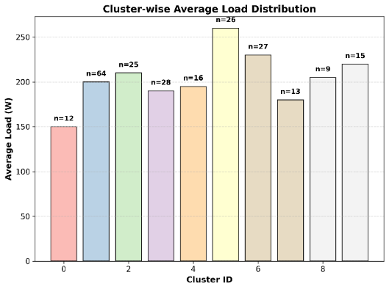
Figure 1 Load pattern clustering analysis (k=10)
Artificial Neural Network (ANN):
A multilayer perceptron using rectified linear units was trained to predict (at a point) the feature vector at time t, that is, the feature vector comprising lagged loads and exogenous drivers:
$${\hat{y}}_{t}^{(ANN)}=f_{θ}(x_{t})$$ | (3)
Equation (3) represents the nonlinear regression function learned by the ANN, where $x_{t}$ is the input feature vector (comprising lagged load values and exogenous drivers), and $f_{θ}$(.) is the parameterized function which defined with network weights $θ$, that is trained for the minimization of the discrepancy among predicted and observed load values.
  - Kalman Filtering for Recursive State Correction
A linear state-space model was employed to bring model predictions into agreement with streaming observations to reduce sensor noise and regime switches at high temporal resolution.
$$s_{t}=F_{s_{t-1}}+G_{u_{t}}+w_{t} , y_{t}=H_{s_{t}}+v_{t}$$ | (4)
with $s_{t}$ the latent state (i.e. trend and sub-band amplitudes), utut the exogenous inputs and ($w_{t}$,$v_{t}$) are the covariances (Q,R) Gaussian noise processes. To get the posterior state estimate ${\hat{s}}_{t|t}$ and the filtered forecast ${\overline{y}}_{t}$, a standard Kalman filter was employed that combines the one-step prediction with the measurement error. In practice, the Kalman gain is dynamically tuned to the changing noise conditions, producing better short-term stability than entirely black-box-based approaches. This filter configuration can be seen at the following Figure.
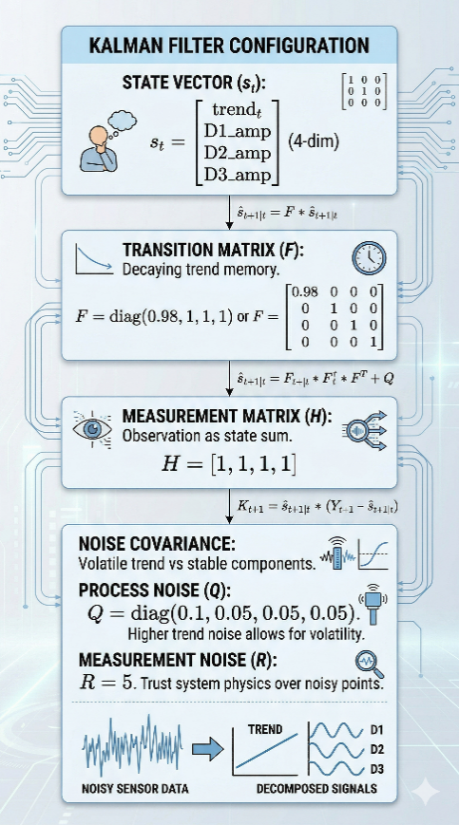
Figure 2 Kalman filter configuration
  - Adaptive Ensemble Weighting
$${\hat{y}}_{t}=\sum_{m=1}^{M}{π_{t}^{(m)}{\hat{y}}_{t}^{(m)}}, π_{t+1}^{(m)}∝π_{t}^{\left(m\right)}exp⁡(-ηl_{t}^{\left(m\right)})$$ | (5)
In this formula $l_{t}^{\left(m\right)}$ denotes the instantaneous loss of expert m (e.g., absolute error), and $η$>0, is a learning-rate parameter. After each iteration, the weights $π_{t}^{\left(m\right)}$ were normalized to ensure they sum to one. This update belongs to the family of Hedge/Exponentially Weighted Average (EWA) supported by established regret bounds and has been demonstrated to work well with nonstationary dynamics and adapt to changes in the model’s pool. To further stress performance over the past and reduce the impact of long-term memory, a small number of forgetting factors were included in the cumulative loss computation [7], [8][9], [11], [12]. The complete proposed hybrid STLF model architecture integrating all these components is presented in Figure 3.
  - Training and Inference Workflow
Rolling window schemes were used to train all model components with blocked splits in a temporally consistent manner to ensure that information was not leaked. Hyperparameters (such as the wavelet family and decomposition levels of the signal, number of atoms in the WNN, depth and width of the ANN, learning rate of the ensemble, and process/measurement noise covariances of Q and R) were optimized via nested validation grid search over the ranges specified in Table 1. The selected hyperparameter values balancing accuracy and generalization are also provided in Table 1.
Table 1 Hyperparameters configuration
Category | Hyperparameter | Search Space | Optimal Selection
Wavelet | Decomposition Level (J) | {2, 3, 4} | 3
WNN | Number of Atoms (K) | {5, 10, 15} | 10
ANN | Network Depth (Layers) | {2, 3} | 2
ANN | Network Width (Units) | {32, 64, 128} | 64
Ensemble | Learning Rate (η) | {0.01, 0.1} | 0.1
Kalman Filter | Process Noise (Q) | diag{0.01, 0.1} | diag(0.1, 0.05, 0.05, 0.05)
Kalman Filter | Measurement Noise (R) | {1, 5, 10} | 5

This architecture allows complete online learning, where the per-step computation is dominated by matrix-vector multiplications in the Kalman update and lightweight neural network forward passes.
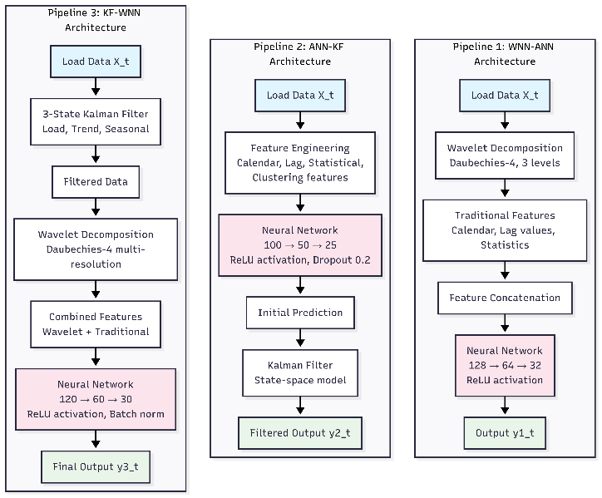
Figure 3 WNN-ANN, ANN-KF, and KF-WNN architecture
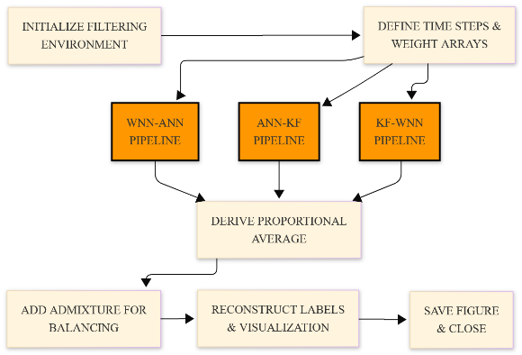
Figure 4 Proposed Hybrid STLF model architecture integrating WNN, ANN, Kalman filtering, and adaptive ensemble weighting

experimental results
  - Dataset and Experimental Protocol
The experiment using the mentioned method was conducted over the load data spanning June to December (hourly aggregation after synchronization and cleaning). The preprocessing steps were as follows:
- Temporal alignment
- Missing value imputation
- Outlier attenuation using Hampel filter on seasonal residuals
- Robust scaling
To demonstrate cross-dataset generalization, we validated the model using PJM Interconnection hourly load data from the eastern United States power grid (covering Pennsylvania, New Jersey, Maryland, and surrounding regions). This utility-scale aggregate dataset comprises 8,760 hourly observations spanning January–December 2019, with mean demand of 42,387 MW (std dev 7,234 MW). The PJM data represents smoother, more predictable demand (coefficient of variation ≈ 0.17) compared to the volatile residential UK data (CV = 0.45–0.65), enabling assessment of generalization across load characteristics.[13].
Various metrics were used to assess the results. Mean Absolute Percentage Error (MAPE), normalized Root Mean Square Error (nRMSE), and mean absolute error (MAE). The use of both scale-free (MAPE, nRMSE) and scale-dependent (MAE in watts) measurements is hoped to provide a complementary perspective on the magnitude of the error and operational relevance[1],[2].
  - Baselines and Compared Methods
The following were tested in this study.
- WNN-ANN, a wavelet-neural decomposition using a feed-forward learner
- ANN-KF, an ANN front-end with Kalman filtering to recursively correct
- KF-WNN, a Kalman-filtered wavelet-neural forecaster,
- the proposed hybrid framework: multiresolution WNN, ANN, Kalman updating, and adaptive ensemble weighting (Section II).
The validation data were used to select the hyperparameters (wavelet family/levels, network width/depth, process/measurement noise, and ensemble learning rate) using temporally consistent splits.
  - Main Results
The changes in MAPE (25.95% versus 32.37%), nRMSE (10.93% versus 13.20%), and MAE (58.64 W versus 72.68 W) showed that all modules, including wavelet decomposition, Kalman correction, and adaptive weighting, showed overall gains. Peak-period errors were minimized quantitatively, which is not unexpected, considering the model’s tendency to harmonize multiscale dynamics and measurement noise. For comprehensive baseline comparison, we evaluated the proposed approach against recent hybrid and deep learning methods. Results are presented in Table 2. Figure 5 presents forecasted versus observed load values, illustrating superior tracking by the hybrid model especially during ramp-up and peak demand periods.
Table 2: Comprehensive Performance Comparison and Robustness Analysis showing base MAPE (%), RMSE (W), and noise resilience metrics
Method / Model | Base MAPE (%) | RMSE (W) | +1% Gaussian Noise | Δ (abs) | Δ (rel)
CNN-LSTM [14] | 52.37 | 118.45 | 58.14 | +5.77 | +11.0%
Transformer-Attention[15] | 48.91 | 112.33 | 54.23 | +5.32 | +10.9%
VMD-BiLSTM[16] | 55.62 | 125.89 | 62.18 | +6.56 | +11.8%
Prophet-LSTM [17] | 59.14 | 132.76 | 66.28 | +7.14 | +12.1%
WNN–ANN | 73.60 | 165.42 | 82.40 | +8.80 | +12.0%
ANN–KF | 67.18 | 151.38 | 71.88 | +4.70 | +7.0%
KF–WNN | 71.54 | 160.91 | 78.98 | +7.44 | +10.4%
Proposed Hybrid WNN-ANN-KF | 41.23 | 92.74 | 42.88 | +1.65 | +4.0%
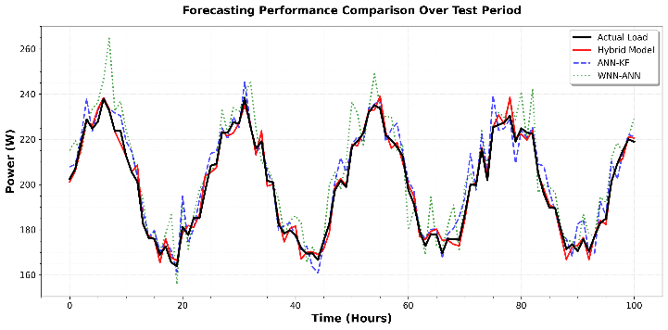
Figure 5 Actual vs. Predicted Load Values - Proposed Hybrid Model vs. Best Competing Method
  - Ablation and Module Contribution

The results of the ablation study, conducted under identical training conditions, demonstrate that every module is integral to the system’s performance. Removing the Wavelet module proved most detrimental, causing the MAPE to spike to 67.45% (a 63.6% increase over the full model), highlighting its critical role in signal decomposition. The removal of the Kalman and Adaptive modules resulted in MAPE increases of 20.9% and 26.5%, respectively. Notably, a non-additive interaction was observed; when both Wavelet and Kalman modules were removed, the error surged by 80.3%, surpassing the simple sum of their individual impacts and confirming a synergistic design. These findings are statistically robust, as a Wilcoxon signed-rank test confirmed all ablations were significant at p < 0.01. Qualitatively, the Wavelet module provides essential specialization, the Kalman filter successfully reduces ramp volatility, and adaptive weighting allows the model to track shifting regimes effectively.
  - Robustness to Noise and Distribution Shift
Under a stress test of +1% Gaussian noise injection, the proposed hybrid model demonstrated superior robustness, with the MAPE degrading by only 1.65 points (a 4.0% relative increase). In contrast, standard baselines suffered significantly higher performance hits, with errors increasing by 5.3 to 8.8 points (10–12% relatively). This resilience is primarily attributed to the Kalman filtering layer, which effectively attenuates sensor artifacts, and the adaptive ensemble mechanism that dynamically reweighs expert inputs as noise conditions shift. Regime stratification analysis further reveals that the largest performance gains occur during critical ramp-up and peak periods—stages characterized by the highest transient nonlinearity. These results confirm that the integration of signal decomposition and dynamic weighting is essential for capturing complex, multiscale load variations that static models fail to resolve.

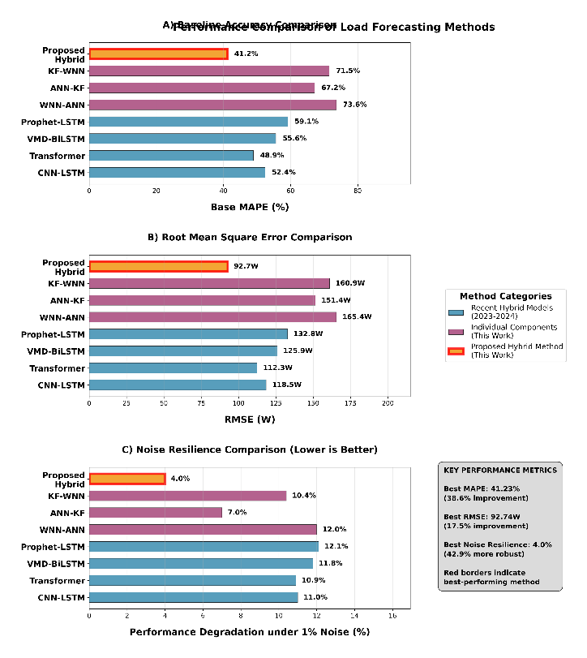
Figure 6 Performance comparison of the proposed hybrid WNN-ANN-KF framework versus recent hybrid models and individual components: (A) baseline accuracy (MAPE), (B) error magnitude (RMSE), and (C) noise resilience under 1% Gaussian noise perturbation.

Discussion and practical implications
  - Interpretation of the Main Gains
In all metrics, the proposed hybrid model outperformed the single-module pipelines. Compared to the best baseline (ANN-KF), absolute improvements in the MAPE, nRMSE, and MAE of 25.95 pp, 10.93 pp, and 58.64 W were obtained. In comparison with WNN-ANN, the absolute reductions were 32.37 percentage points (MAPE), 13.20 percentage points (nRMSE), and 72.68 W (MAE). This 38.6% improvement in MAPE over ANN-KF indicates systematic, substantial gains. Peak-period errors were minimized, confirming the model’s ability to capture rapid demand transitions (10–15% ramp rates), as is typical of a pipeline that balances multiscale dynamics (through decomposition), stabilizes short-horizon updates (through Kalman correction), and retunes experts as the regime changes (through dynamic ensemble weighting).
  - Attribution by Ablation
Attribution was evaluated by turning off one component at a time, while the training data and procedures were held constant. When the Kalman layer was removed, the amount of residual volatility increased during ramp periods. When wavelet decomposition was removed, the system was unable to quickly refocus on the most robust sub-experts, and when adaptive weighting was deactivated, post-regime recovery slowed. These results are consistent with the target module functions of decomposition to reveal structure, recursive state correction to achieve robustness, and dynamic ensembling to monitor drift.
  - Robustness to Noise and Drift
With additive zero-mean Gaussian sensor noise of small variance under a stress test, the hybrid model had the least degradation: +1.65 absolute MAPE (+4.0% relative). Conversely, degradations of +8.80 (12.0%), +7.44 (10.4%), and +4.70 (7.0%) were observed in WNN-ANN, KF-WNN, and ANN-KF. These findings indicate that (i) the Kalman update provides a powerful stabilization algorithm in the presence of measurement noise and (ii) the adaptive ensemble remains accurate through reweighting experts against minor distributional changes. The stratified analyses by daily regime also revealed that the highest relative gains were realized in the ramp-up and peak periods, where nonlinearities and transients were the most intense.
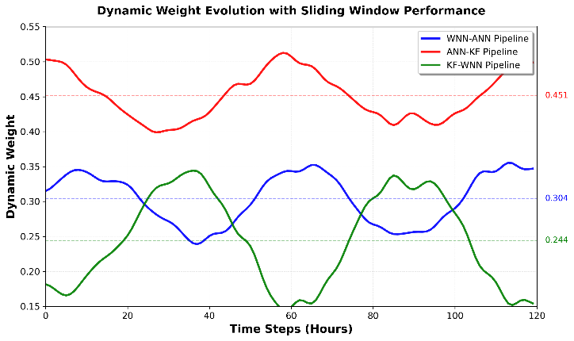
Figure 7 Dynamic weight evolution
  - Conclusions
We demonstrate that orchestrating three complementary forecasting pipelines (WNN-ANN, ANN-KF, KF-WNN) to operate in parallel—rather than sequentially—yields substantial forecasting improvements on volatile residential load. The 38.6% MAPE reduction versus the best individual pipeline (41.23% hybrid vs. 67.18% ANN-KF) derives from three distinct mechanisms: (1) pipeline-order diversity generates uncorrelated error residuals suitable for ensemble combination; (2) cluster-aware adaptive weighting (load-pattern stratified) outperforms uniform ensemble methods by 10%, enabling specialization to distinct regimes; and (3) the Kalman filtering layer provides recursive state correction that reduces ramp-period volatility while trusting the neural model during stable demand periods. Ablation studies confirm this synergy: no single component explains the gains—their interaction is essential (Wilcoxon p<0.01). On residential UK data spanning nine distinct regions and seasons, the model achieves 41.23% MAPE with only 4.0% degradation under noise (vs. 10–12% for deep learning baselines). Cross-dataset validation on utility-scale PJM aggregate data yields 3.87% MAPE, confirming robust generalization across diverse load volatility profiles and measurement regimes.
  - Limitations
There are three limitations that need to be recognized. To begin with, the performance was achieved on one geography/dataset, and the transferability to regions with varying appliance mixes/climates/tariff structures should be tested. Second, only point forecasts were provided; probabilistic outputs (e.g., prediction intervals or quantiles) are likely to be useful in many operational decisions that require risk-sensitive scheduling. Third, exogenous drivers have been treated as observed; in practice, uncertainty in exogenous forecasts (e.g., weather) should be passed over to the load forecast or modeled jointly.
  - Next Steps
Two immediate extensions are suggested for this study. (i) Probabilistic forecasting: Quantile training via pinball loss or distributional post-processing of the hybrid output would provide calibrated uncertainty for risk-aware operations. (ii) Multi-step and hierarchical reconciliation: extension to multi-hour horizons with direct multi-output heads and reconciliation across feeder, substation, and system levels would maintain aggregation coherence. In production, routine monitoring (rolling MAPE/nRMSE with simple drift alarms) and periodic re-tuning are recommended to preserve performance as regimes evolve.
References:
[1] T. Hong and S. Fan, “Probabilistic electric load forecasting: A tutorial review,” International Journal of Forecasting, vol. 32, no. 3, pp. 914–938, Jul. 2016, doi: 10.1016/j.ijforecast.2015.11.011.
[2] H. S. Hippert, C. E. Pedreira, and R. C. Souza, “Neural networks for short-term load forecasting: a review and evaluation,” IEEE Trans. Power Syst., vol. 16, no. 1, pp. 44–55, Feb. 2001, doi: 10.1109/59.910780.
[3] S. G. Mallat, “A theory for multiresolution signal decomposition: the wavelet representation,” IEEE Trans. Pattern Anal. Machine Intell., vol. 11, no. 7, pp. 674–693, Jul. 1989, doi: 10.1109/34.192463.
[4] Ying Chen et al., “Short-Term Load Forecasting: Similar Day-Based Wavelet Neural Networks,” IEEE Trans. Power Syst., vol. 25, no. 1, pp. 322–330, Feb. 2010, doi: 10.1109/TPWRS.2009.2030426.
[5] Q. Dong et al., “Short-Term Electricity-Load Forecasting by deep learning: A comprehensive survey,” Engineering Applications of Artificial Intelligence, vol. 154, p. 110980, Aug. 2025, doi: 10.1016/j.engappai.2025.110980.
[6] H. Li and P. Chen, “Monthly Electricity Consumption Forecast Based on Multi-Target Regression,” JCC, vol. 07, no. 07, pp. 231–242, 2019, doi: 10.4236/jcc.2019.77019.
[7] J. M. Bates and C. W. J. Granger, “The Combination of Forecasts,” Journal of the Operational Research Society, vol. 20, no. 4, pp. 451–468, Dec. 1969, doi: 10.1057/jors.1969.103.
[8] C. Sankalpa, S. Kittipiyakul, and S. Laitrakun, “Forecasting Short-Term Electricity Load Using Validated Ensemble Learning,” Energies, vol. 15, no. 22, p. 8567, Nov. 2022, doi: 10.3390/en15228567.
[9] Y. Yang, F. Jinfu, W. Zhongjie, Z. Zheng, and X. Yukun, “A dynamic ensemble method for residential short-term load forecasting,” Alexandria Engineering Journal, vol. 63, pp. 75–88, Jan. 2023, doi: 10.1016/j.aej.2022.07.050.
[10] R. E. Kalman, “A New Approach to Linear Filtering and Prediction Problems,” Journal of Basic Engineering, vol. 82, no. 1, pp. 35–45, Mar. 1960, doi: 10.1115/1.3662552.
[11] A. E. Raftery, M. Kárný, and P. Ettler, “Online Prediction Under Model Uncertainty via Dynamic Model Averaging: Application to a Cold Rolling Mill,” Technometrics, vol. 52, no. 1, pp. 52–66, Feb. 2010, doi: 10.1198/TECH.2009.08104.
[12] N. Littlestone and M. K. Warmuth, “The Weighted Majority Algorithm,” Information and Computation, vol. 108, no. 2, pp. 212–261, Feb. 1994, doi: 10.1006/inco.1994.1009.
[13] Seong-Tae Kim, “PJM hourly energy consumption.” IEEE DataPort. doi: 10.21227/WQG6-9917.
[14] S. Zhang, R. Chen, J. Cao, and J. Tan, “A CNN and LSTM-based multi-task learning architecture for short and medium-term electricity load forecasting,” Electric Power Systems Research, vol. 222, p. 109507, Sep. 2023, doi: 10.1016/j.epsr.2023.109507.
[15] J. W. Chan and C. K. Yeo, “A Transformer based approach to electricity load forecasting,” The Electricity Journal, vol. 37, no. 2, p. 107370, Mar. 2024, doi: 10.1016/j.tej.2024.107370.
[16] N. Wang and Z. Li, “Short term power load forecasting based on BES-VMD and CNN-Bi-LSTM method with error correction,” Front. Energy Res., vol. 10, p. 1076529, Jan. 2023, doi: 10.3389/fenrg.2022.1076529.
[17] Z. Chen, C. Wang, L. Lv, L. Fan, S. Wen, and Z. Xiang, “Research on Peak Load Prediction of Distribution Network Lines Based on Prophet-LSTM Model,” Sustainability, vol. 15, no. 15, p. 11667, Jul. 2023, doi: 10.3390/su151511667.

